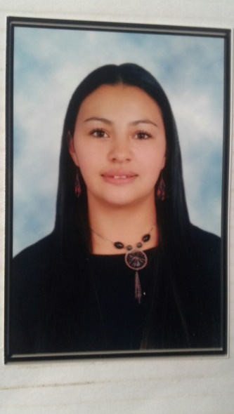

**KAREN DAMARIS ZARATE BLANCO**

**Occupation:** MULTIMEDIA PRODUCER

**Nationality:** colombiana

**Date of birth:** 1990-11-24

**Address:** barrio sotara manzana e casa 5

**Phone:** (+57)3142635114

**Email:** krenz06@hotmail.com

**OBJETIVE**

I'm a multimedia project manager. I'm in charge of monitoring multimedia projects. I Create and adapt visual communication materials.I manipulate and edit video and audio pieces to create audiovisual pieces like films.

**EXPERIENCE**

MULTIMEDIA PRODUCER

creative productions

mosquera

2019-03 - 2021-11

creator of multimedia content, with extensive experience in commercial consulting and advertising.

**EDUCATION**

The National Training Service SENA, Bogotá D.C. June 2015 Multimedia Production Technology

programming

universidad sergio arboleda

colombia, 2021-06 - Present

I am currently studying.

**SKILLS**

• Trabajo en equipo

• Resolución de problemas

• Atención al cliente

• Liderazgo

LANGUAGES

• English, Advanced

.